# [BW2HANA Authorization Generation](https://wiki.scn.sap.com/wiki/display/BI/BW2HANA+Authorization+Generation)

## Overview

In order to be able to access the [External HANA views](https://wiki.scn.sap.com/wiki/x/DpM8Gg) which have been generated by the BW system, some general object privileges to access schemas _SYS_BI and _SYS_BIC and to run SELECT statements on the view, and data authorizations /SQL Analytic Privileges/ are needed. In tr. **RS2HANA_VIEW** there are some important settings which have an impact on the way how authorizations are assigned to HANA users

##### BW75 System(SP16)

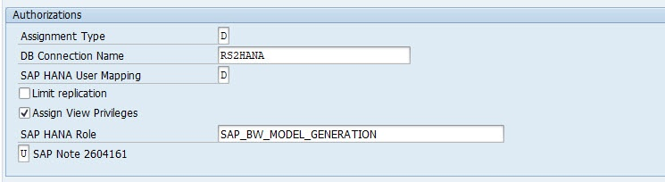

##### BW/4Hana 2.0 System

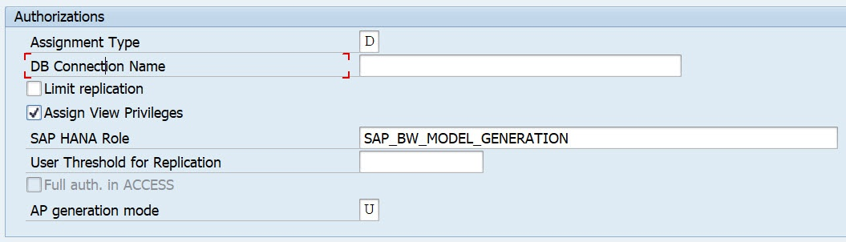

## Examples

* *AP Mode ' '* - dynamic analytic privileges using stored procedures: [Example I](https://wiki.scn.sap.com/wiki/display/BI/BW2HANA+authorization+generation%3A+Example+I)
* *AP Mode S* - static analytic privileges using SQL SELECT statements: [Example III](https://wiki.scn.sap.com/wiki/display/BI/BW2HANA+Authorization+Generation%3A+Example+III)
* *AP Mode U* - static user-specific analytic privileges: Example [Example II](https://wiki.scn.sap.com/wiki/display/BI/BW2HANA+Authorization+Generation%3A+Example+II)

## Transactions

* *RS2HANA_CHECK* - checks all of the required prerequisites for a successful replication of the BW authorizations.
* *RS2HANA_ADMIN* - displays an overview of all of the BW objects with an external SAP HANA view. Allows you to manage the views from BW Objects. Check and repair the HANA views themselves in transaction RS2HANA_ADMIN.
* *RS2HANA_GEN* /same as SE38 report RS2HANA_AUTH_RUN/ - replicate BW Analysis Authorizations to Hana. Complete clean-up and re-build of generated HANA privileges.
* *RS2HANA_VIEW* - make central settings in relation to the external SAP HANA view. SAP HANA authorizations are assigned to one user. You can define how this user is generated here.

**Analytic Privileges**

To be able *to access SAP HANA views* that have been generated from the BW system, you need the following authorizations

* Object privilege - *SELECT* on _*SYS_BI* and *EXECUTE* on *REPOSITORY_REST*(SYS).
* Package privilege - REPO.READ on the content package where generated SAP HANA views are stored.

## You can use tr. RS2HANA_GEN to *generate Analytic Privileges* and assign them to the required Hana database users *for*[*External SAP HANA Views*](https://wiki.scn.sap.com/wiki/display/BI/External+SAP+HANA+Views). If this is successful, these users are allowed to run SQL statements accessing the External Hana View.

## However, these authorizations are not sufficient when the user wants to take a look at the generated view in the Hana Studio /e.g. use DataPreview/. It is also not possible to add the External Hana View to a Hana Calculation View since it wouldn't be offered.

## In order to enhance the privileges for the db users accordingly, you need to assign the Default Database Privileges to the DBMS Users. This has to be done only once since the privileges do not depend on a certain External Hana View but rather allow the user to access all objects from the corresponding package. You can use transaction RS2HANA_GEN and then select from the menu *GoTo→Assign General Privileges* /report RS2HANA_ASSIGN_PRIVILEGES/ - Тр. RS2HANA_GEN – Replicate BW Analysis Authorization to SAP HANA.

## Или вручную для пользователя, у которого не выполняется првью для CV – во вкладке Analytic Privileges – добавить объекты используемые для построения CV.

## *Rem*

## tr. RS2HANA_GEN используется - если пользователь bw не совпадает с пользователем БД.

Analytic Privileges are only applied *to attributes* in an Information View. We cannot add measures to restrict access in Analytic privileges.

**Creating Analytic Privileges**

Right Click on Package name and go to new Analytic Privilege or you can open using HANA Modeler quick launch.

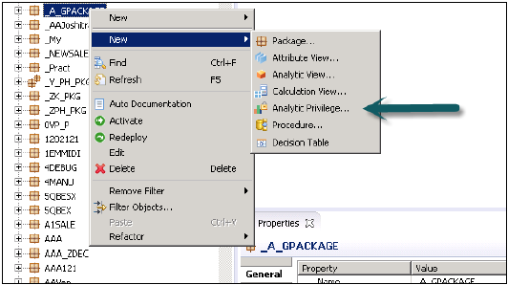

Enter name and Description of Analytic Privilege → Finish. New window will open.

# [**Hana Models with associated Analytic Privileges**](https://wiki.scn.sap.com/wiki/display/BI/Hana+Models+with+associated+Analytic+Privileges)

<https://wiki.scn.sap.com/wiki/display/BI/Hana+Models+with+associated+Analytic+Privileges>

***There are two types of analytic privileges***

1. ***SQL Analytic Privileges* -** provide the flexibility to create analytic privilges within the familiar SQL enviroment;if a analytic privilege is assigned to a Hana Model, the SAPSID user needs this privilege when a BW query accesses this calculation view.
2. ***Classic Analytic Privileges* -** XML based analytic privileges - normally the SAPSID user has the privilege **_SYS_BI_CP_ALL** which provides full authorization for all Hana Models regarding classic analytic privileges.

# **Example I - SQL Analytic Privileges**

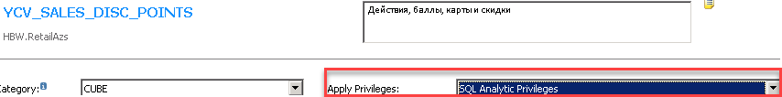

## Checking the Analytic Privileges with the help of SQL Statements

With this statement you get the name of the privilge assigned to a certain calculation view

**select * from structured_privileges where operand like '%*Name of CalcView*%'**

**select * from structured_privileges where operand like '%***YCV_SALES_DISC_POINTS***%'**

This way we get the definition of the privilge

select

STRUCTURED_PRIVILEGE_NAME,

RESTRICTION_TYPE,

NEGATED,

OPERATOR,

OPERAND_ORDER,

OPERAND

from structured_privileges where structured_privilege_name = *'yloy/YAP_ALL*'

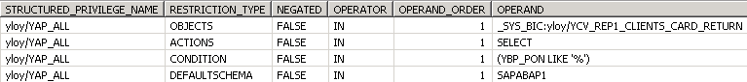

Check whether a user has the authorization to access the calculation view, see structured_privilege_status.

select * from effective_structured_privileges where root_object_name = *'yloy/YCV_SALES_DISC_POINTS'* and root_schema_name = *'_SYS_BIC'* and user_name = *'EKIMENKO'*

# **Example II - Classic Analytic Privileges**

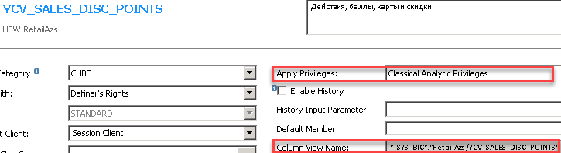

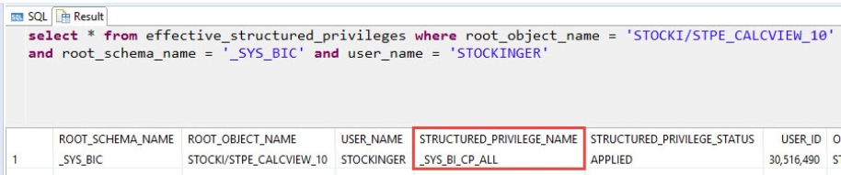

select * from effective_structured_privileges where root_object_name = *'RetailAZS/YCV_SALES_DISC_POINTS'* and root_schema_name = *'_SYS_BIC'* and user_name = *'EKIMENKO'*